NEW YORK INSTITUTE OF TECHNOLOGY

College of Engineering and Computing Sciences

Department of Computer Science Vancouver Campus

Data Structures - 1339481-zhijun-jiang CSCI 615 Research Presentation

**Virtual Network in k8s and the security measure implemented**

Virtual Network in the containization with virtual router ans switches

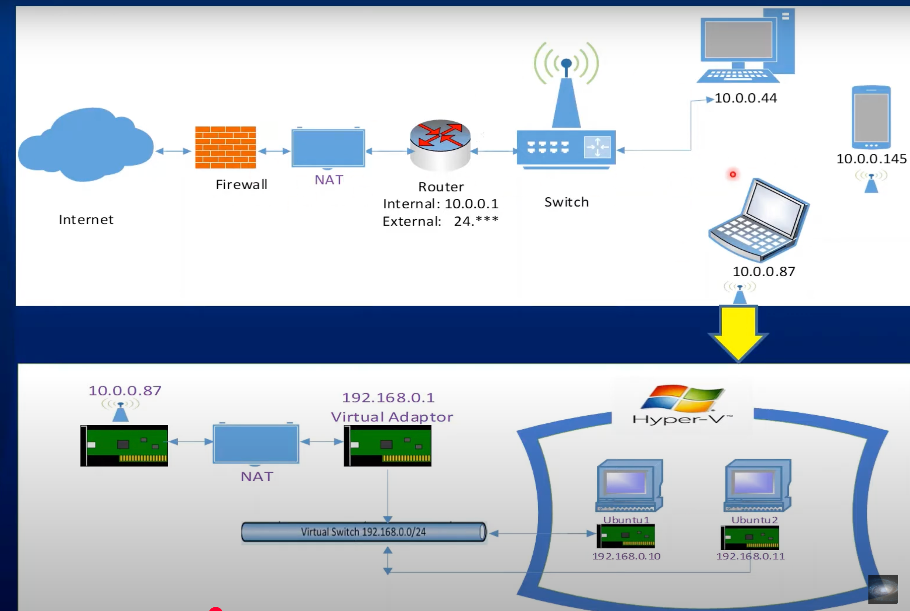

Linux name space to mimic the docker containers. It provides isolation and conmunicate through veth bridge

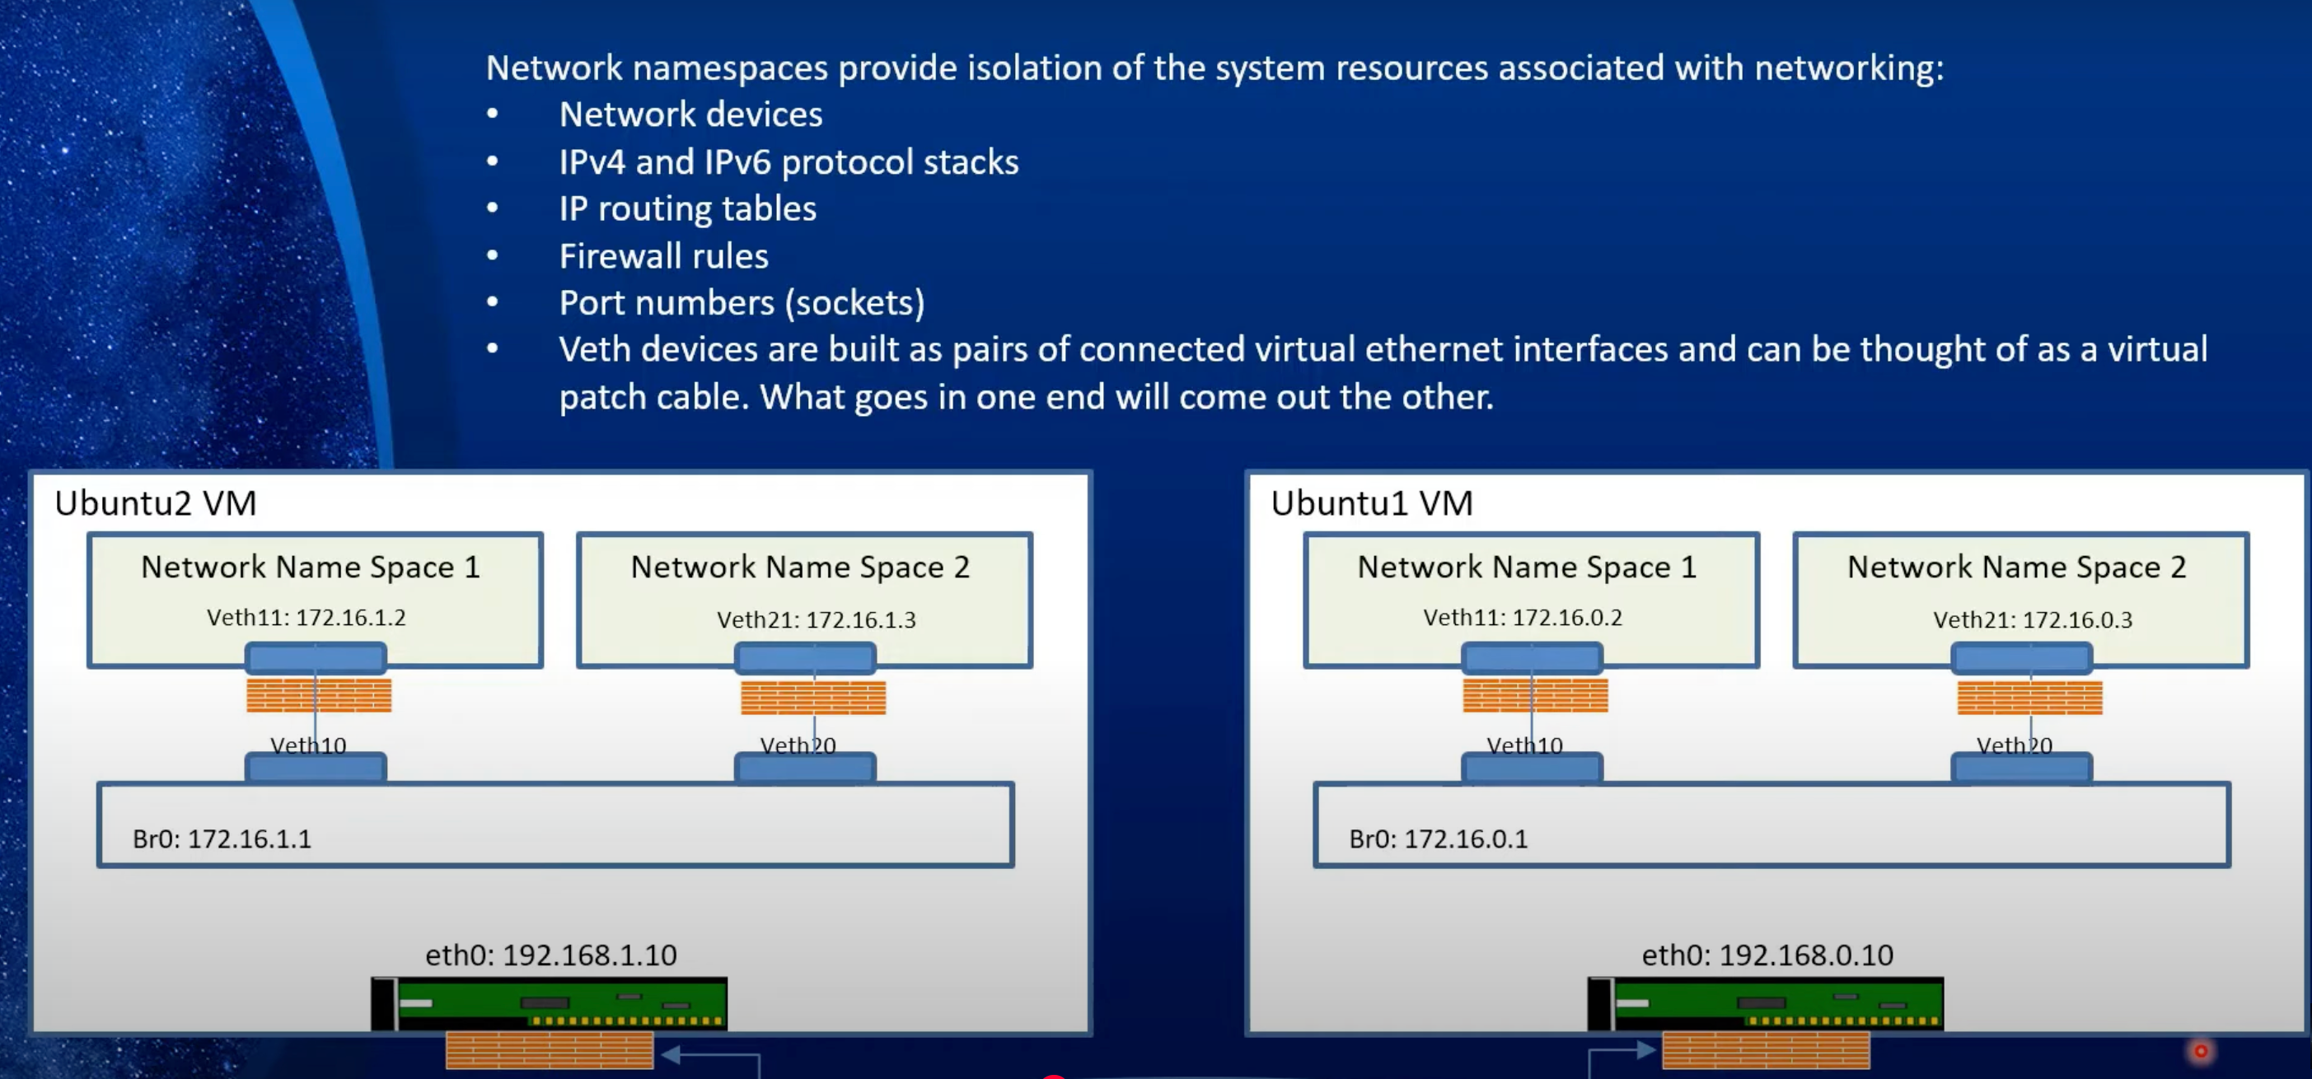

*#!/bin/bash -e*

*#!bash*

NS1="NS1"

NS2="NS2"

NODE_IP="192.168.0.10"

BRIDGE_SUBNET="172.16.0.0/24"

BRIDGE_IP="172.16.0.1"

IP1="172.16.0.2"

IP2="172.16.0.3"

TO_NODE_IP="192.168.0.11"

TO_BRIDGE_SUBNET="172.16.1.0/24"

TO_BRIDGE_IP="172.16.1.1"

TO_IP1="172.16.1.2"

TO_IP2="172.16.1.3"

echo "Creating the namespaces"

sudo ip netns add $NS1

sudo ip netns add $NS2

ip netns show

echo "Creating the veth pairs"

sudo ip link add veth10 type veth peer name veth11

sudo ip link add veth20 type veth peer name veth21

ip link show type veth

*#ip link show veth11*

*#ip link show veth20*

echo "Adding the veth pairs to the namespaces"

sudo ip link set veth11 netns $NS1

sudo ip link set veth21 netns $NS2

echo "Configuring the interfaces in the network namespaces with IP address"

sudo ip netns exec $NS1 ip addr add $IP1/24 dev veth11

sudo ip netns exec $NS2 ip addr add $IP2/24 dev veth21

echo "Enabling the interfaces inside the network namespaces"

sudo ip netns exec $NS1 ip link set dev veth11 up

sudo ip netns exec $NS2 ip link set dev veth21 up

echo "Creating the bridge"

sudo ip link add br0 type bridge

ip link show type bridge

ip link show br0

*#sudo ip link delete br0*

echo "Adding the network namespaces interfaces to the bridge"

sudo ip link set dev veth10 master br0

sudo ip link set dev veth20 master br0

echo "Assigning the IP address to the bridge"

sudo ip addr add $BRIDGE_IP/24 dev br0

echo "Enabling the bridge"

sudo ip link set dev br0 up

echo "Enabling the interfaces connected to the bridge"

sudo ip link set dev veth10 up

sudo ip link set dev veth20 up

echo "Setting the loopback interfaces in the network namespaces"

sudo ip netns exec $NS1 ip link set lo up

sudo ip netns exec $NS2 ip link set lo up

sudo ip netns exec $NS1 ip a

sudo ip netns exec $NS2 ip a

echo "Setting the default route in the network namespaces"

sudo ip netns exec $NS1 ip route add default via $BRIDGE_IP dev veth11

sudo ip netns exec $NS2 ip route add default via $BRIDGE_IP dev veth21

*# ------------------- Step 3 Specific Setup --------------------- #*

echo "Setting the route on the node to reach the network namespaces on the other node"

sudo ip route add $TO_BRIDGE_SUBNET via $TO_NODE_IP dev eth0

echo "Enables IP forwarding on the node"

sudo sysctl -w net.ipv4.ip_forward=1

*#--------------------Tests------------------------------*

*#Ping adaptor attached to NS1*

sudo ip netns exec $NS1 ping -W 1 -c 2 172.16.0.2

*#Ping the bridge*

sudo ip netns exec $NS1 ping -W 1 -c 2 172.16.0.1

*#Ping the adaptor of the second container*

sudo ip netns exec $NS1 ping -W 1 -c 2 172.16.0.3

*#Ping the other server (Ubuntu2)*

sudo ip netns exec $NS1 ping -W 1 -c 2 192.168.0.11

*#Ping the bridge on "Ubuntu2" server*

sudo ip netns exec $NS1 ping -W 1 -c 2 172.16.1.1

*#Ping the first container on "Ubuntu2"*

sudo ip netns exec $NS1 ping -W 1 -c 2 172.16.1.2

*#Ping the second container on "Ubuntu2"*

sudo ip netns exec $NS1 ping -W 1 -c 10 172.16.1.3

In k8s system design, CNI is the part to manage the network

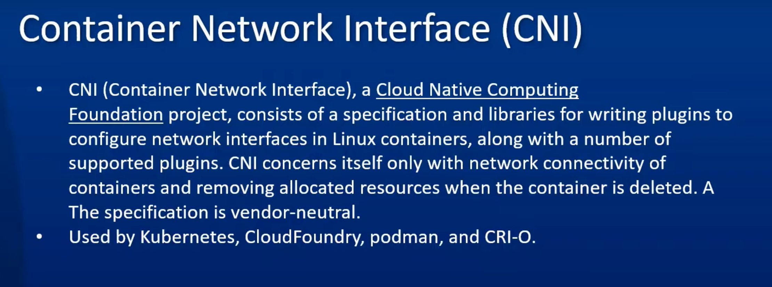

pods communication among the same nodes and different nodes.

same node through the verth and bridge

different nodes through the VXLAN Tunnel

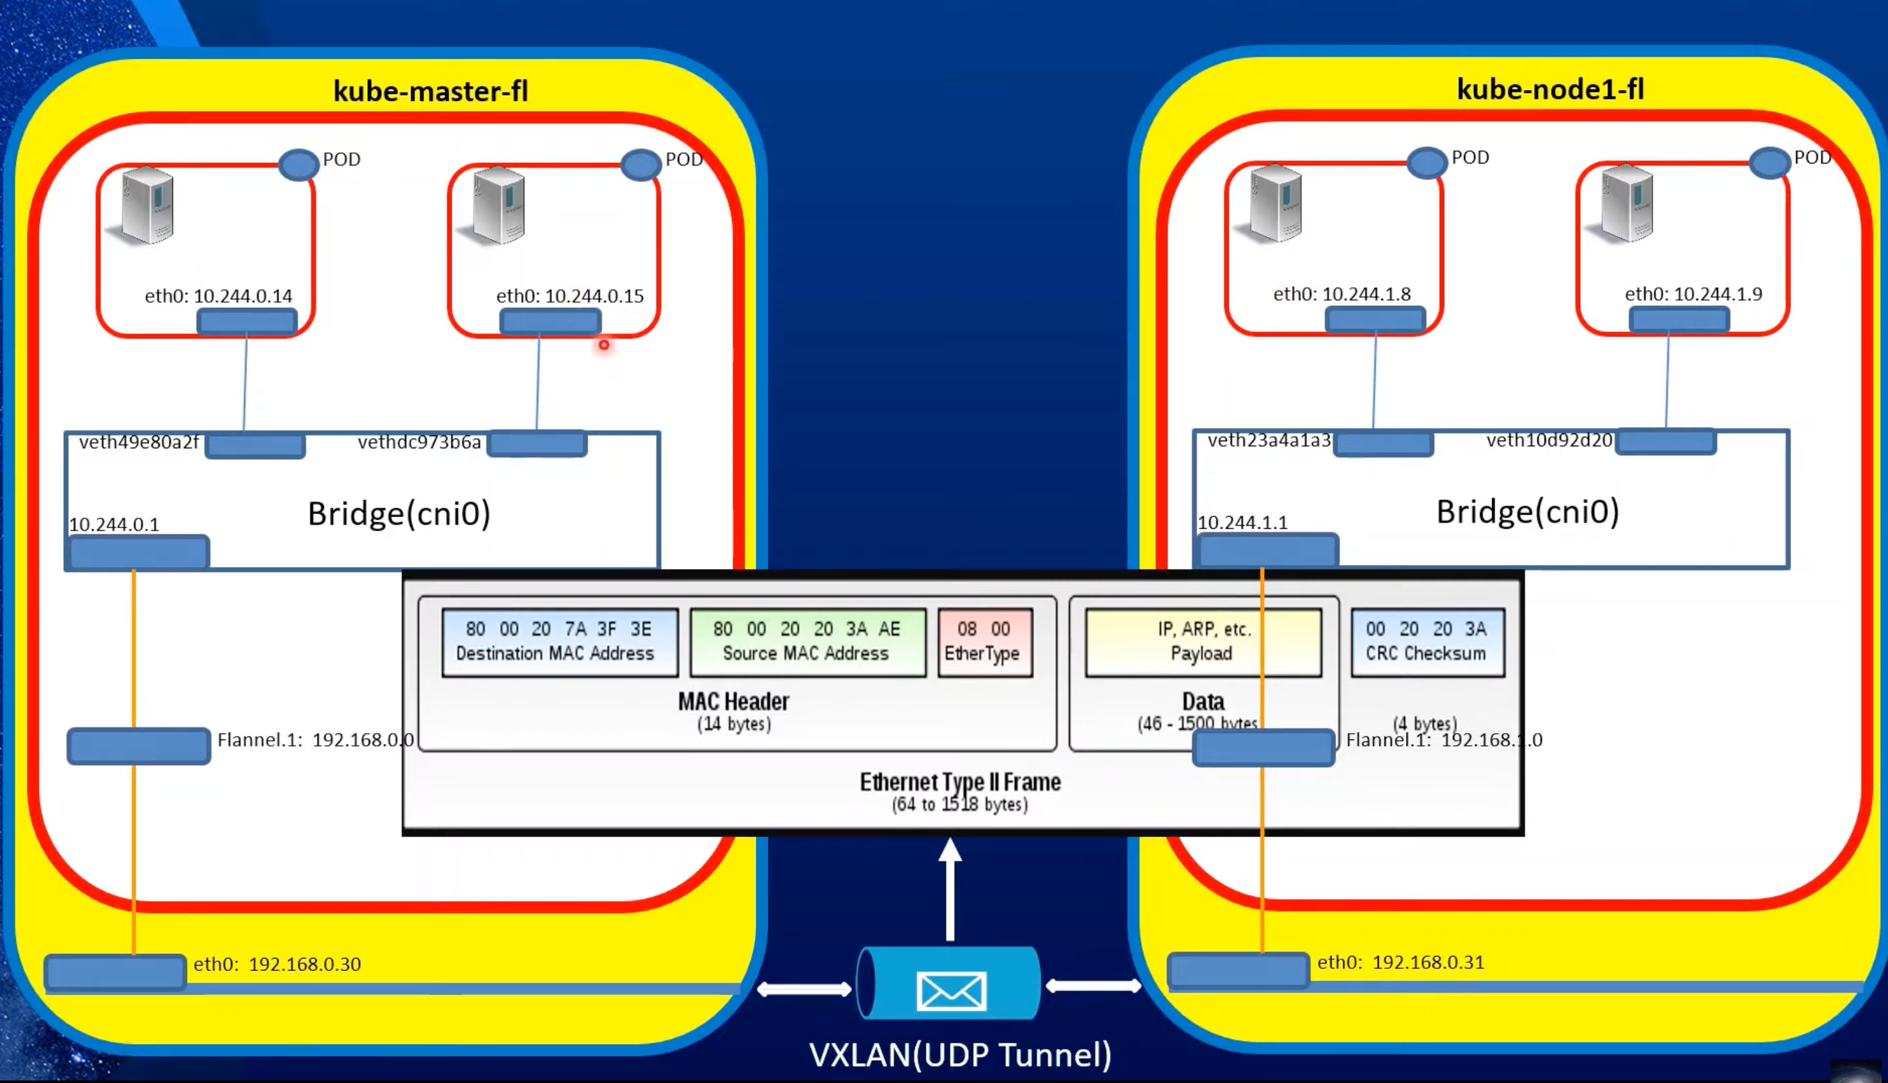

Another CNI implementation is Calico

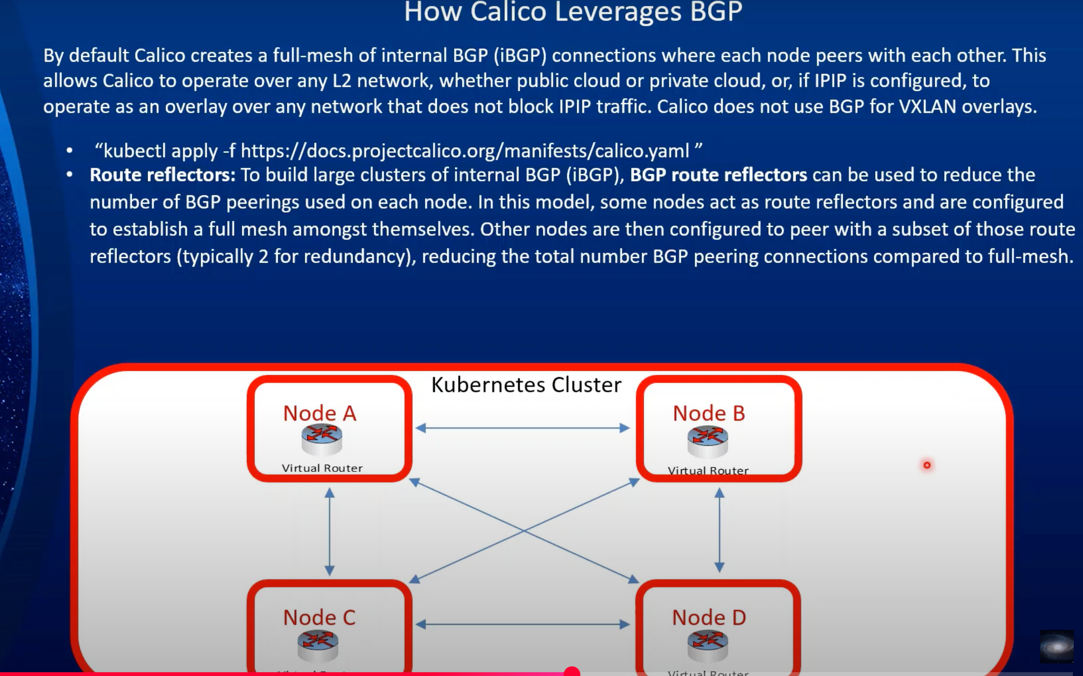

How Calico CNI propagate the pod network

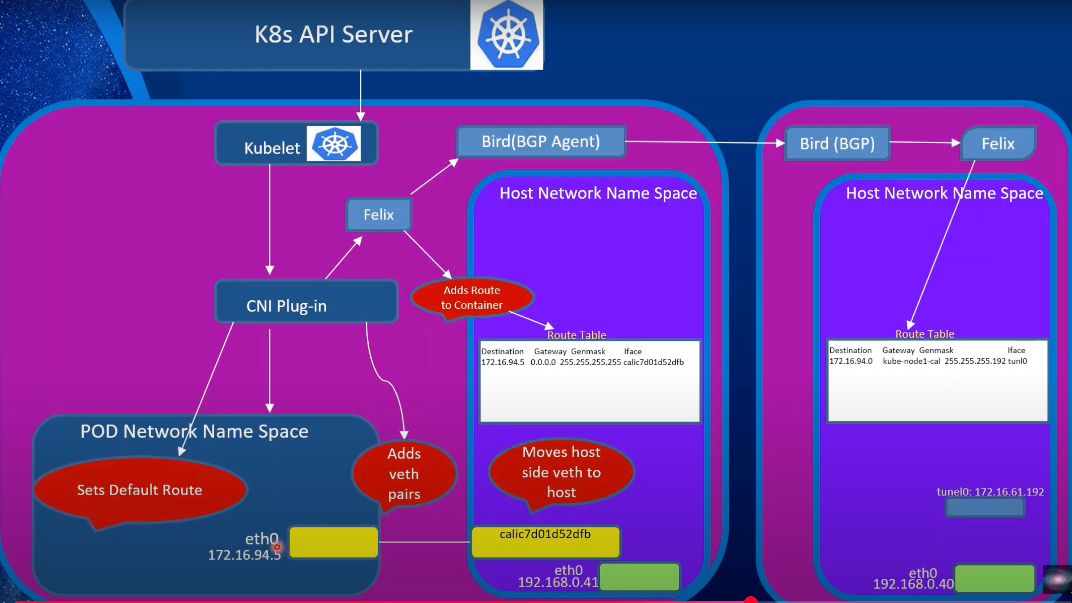

How service works

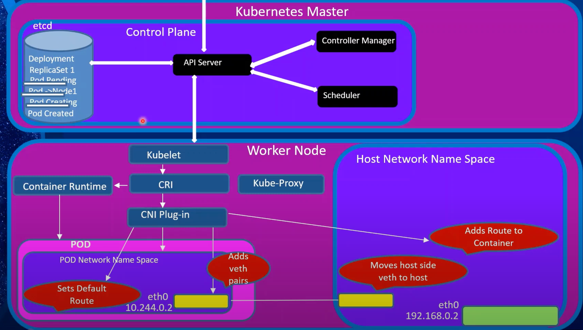

Pod can communicate with each other at the same or different node through the pod IP but what id pod get restarted which can happens very often

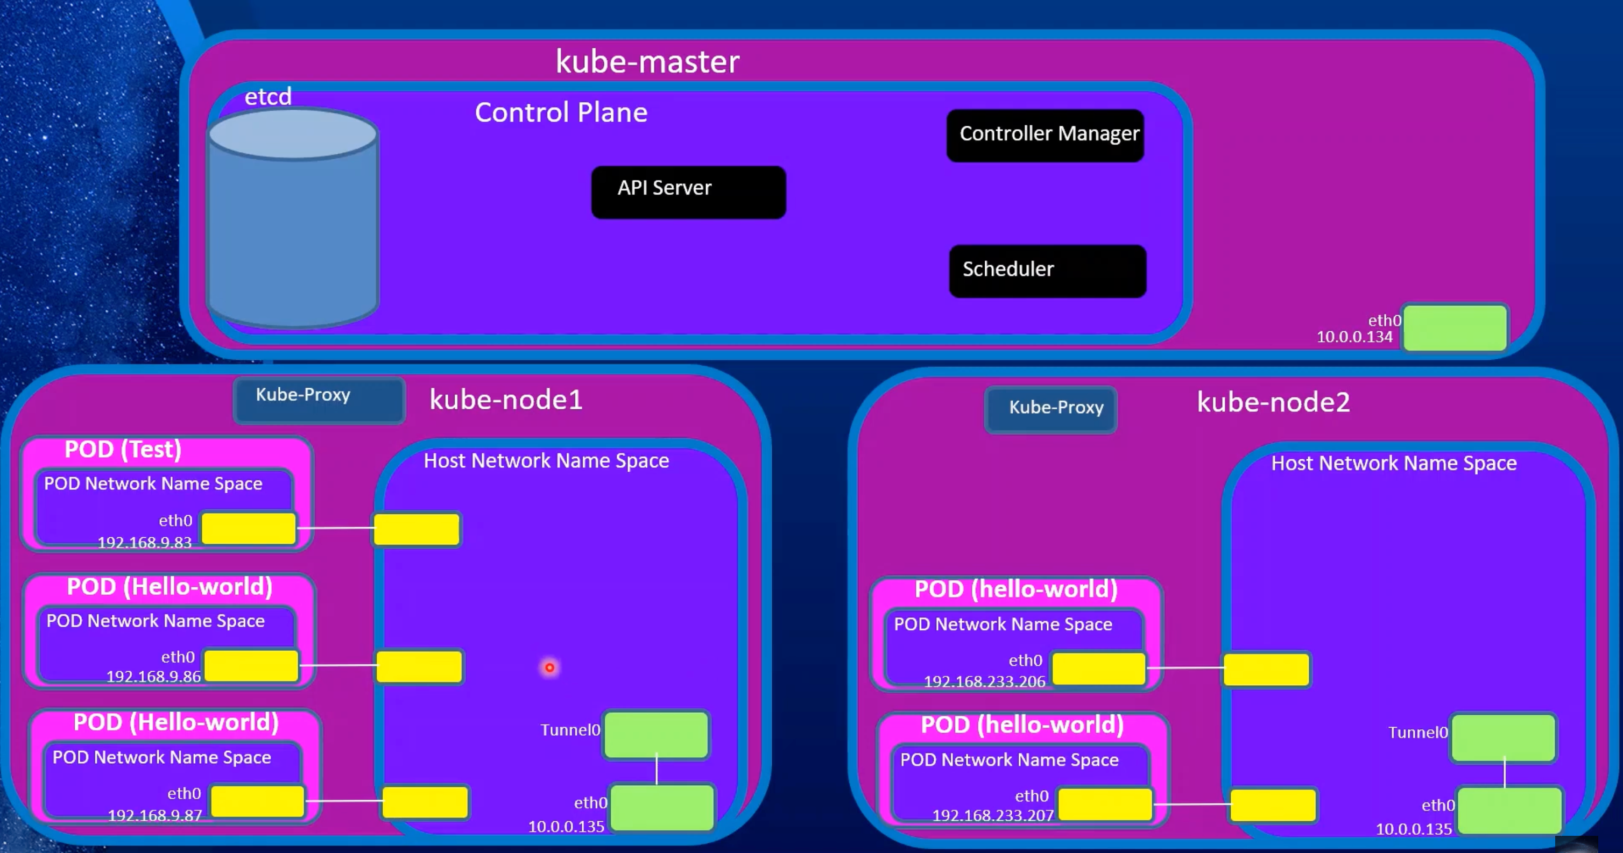

In cluster service leverage iptables to find the pod endpoints

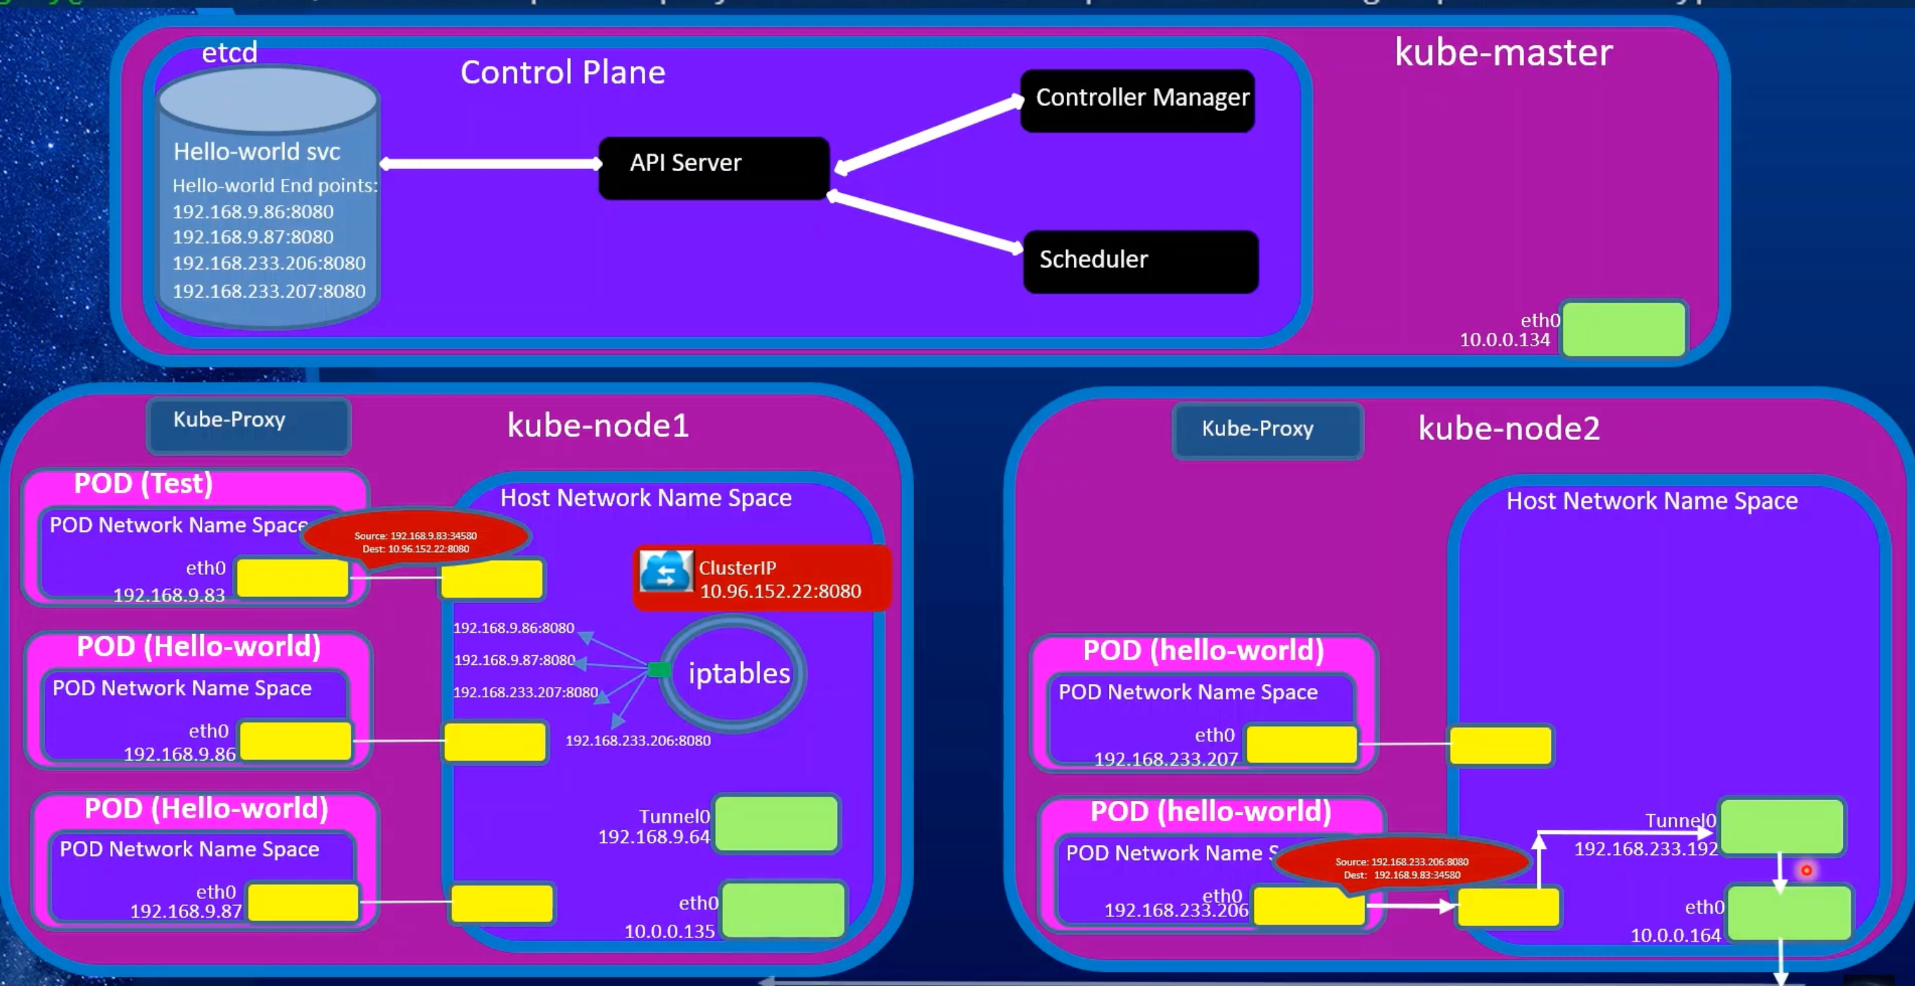

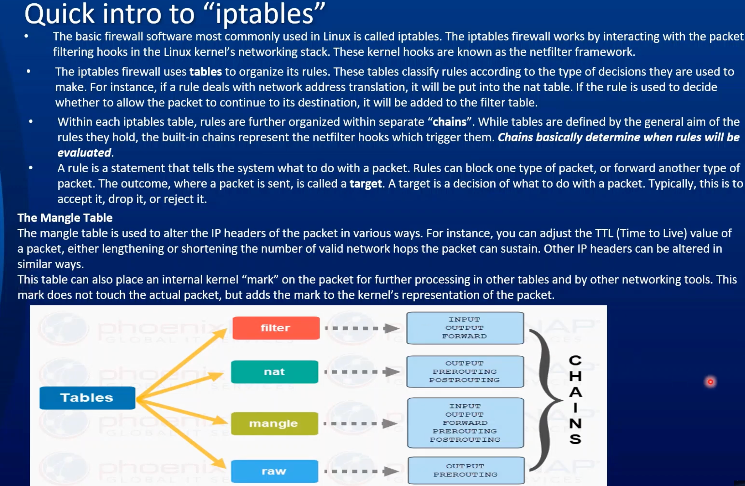

Network policy

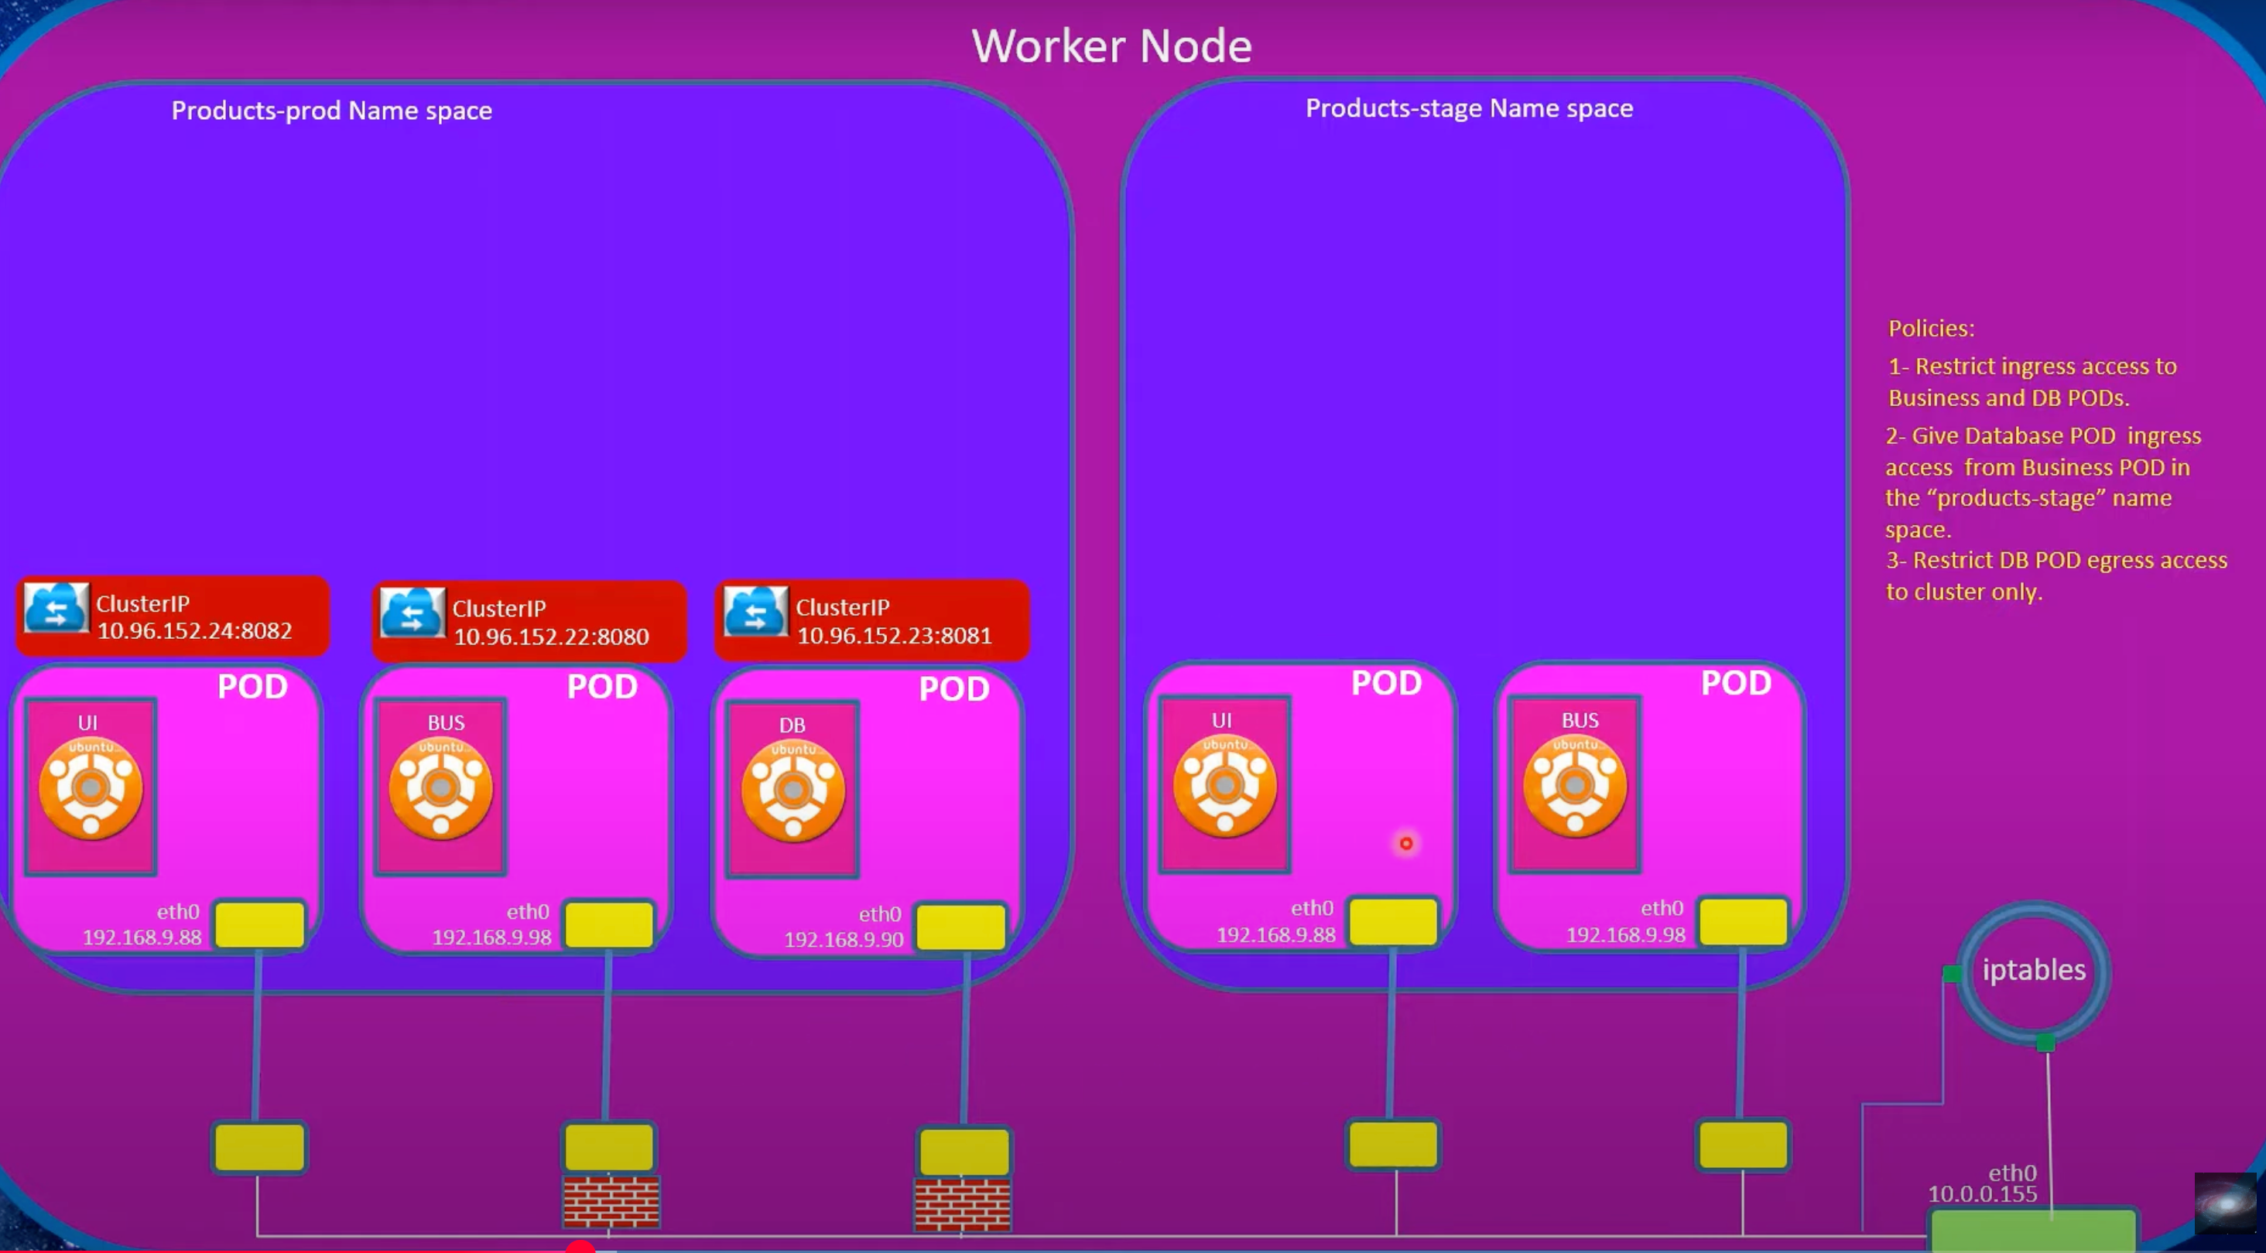

Network policy can select pods with matchLabels and set rules on ingress / Egress

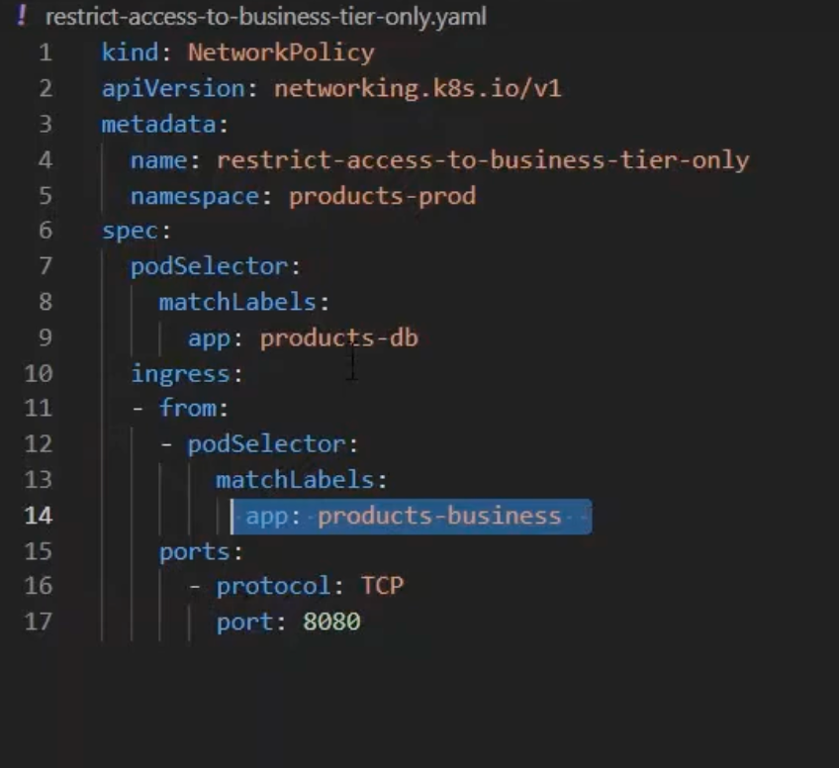

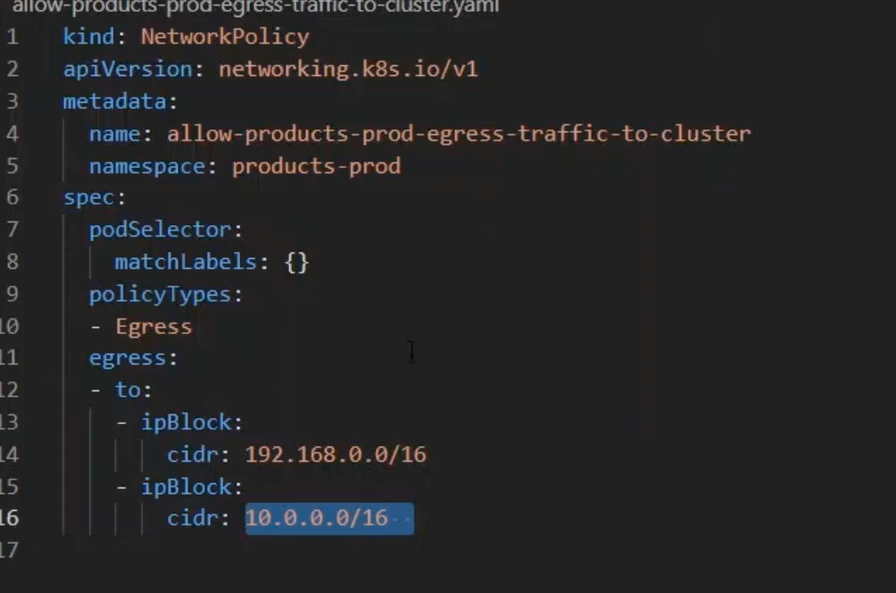

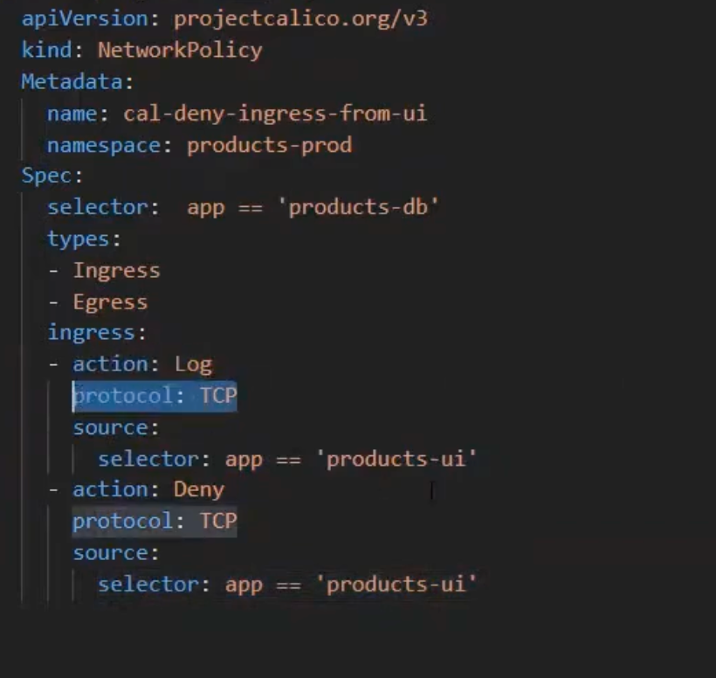

Another Security enhancement is to use Service Account

apiVersion: v1

kind: ServiceAccount

metadata:

labels:

app.kubernetes.io/name: keda-operator

app.kubernetes.io/version: latest

app.kubernetes.io/part-of: keda-operator

name: keda-operator

namespace: keda

Roles : ClusterRoles and Name space Role

---

apiVersion: rbac.authorization.k8s.io/v1

kind: ClusterRole

metadata:

name: keda-operator

rules:

- apiGroups:

- ""

resources:

- configmaps

- configmaps/status

verbs:

- get

- list

- watch

- apiGroups:

- ""

resources:

- events

verbs:

- '*'

- apiGroups:

- ""

resources:

- external

- pods

- secrets

- services

verbs:

- get

- list

- watch

- apiGroups:

- ""

resources:

- limitranges

verbs:

- list

- watch

- apiGroups:

- ""

resources:

- serviceaccounts

verbs:

- list

- watch

- apiGroups:

- '*'

resources:

- '*'

verbs:

- get

- apiGroups:

- '*'

resources:

- '*/scale'

verbs:

- get

- list

- patch

- update

- watch

- apiGroups:

- admissionregistration.k8s.io

resources:

- validatingwebhookconfigurations

verbs:

- get

- list

- patch

- update

- watch

- apiGroups:

- apiregistration.k8s.io

resources:

- apiservices

verbs:

- get

- list

- patch

- update

- watch

- apiGroups:

- apps

resources:

- deployments

- statefulsets

verbs:

- list

- watch

- apiGroups:

- autoscaling

resources:

- horizontalpodautoscalers

verbs:

- '*'

- apiGroups:

- batch

resources:

- jobs

verbs:

- '*'

- apiGroups:

- eventing.keda.sh

resources:

- cloudeventsources

- cloudeventsources/status

verbs:

- '*'

- apiGroups:

- keda.sh

resources:

- clustertriggerauthentications

- clustertriggerauthentications/status

verbs:

- '*'

- apiGroups:

- keda.sh

resources:

- scaledjobs

- scaledjobs/finalizers

- scaledjobs/status

verbs:

- '*'

- apiGroups:

- keda.sh

resources:

- scaledobjects

- scaledobjects/finalizers

- scaledobjects/status

verbs:

- '*'

- apiGroups:

- keda.sh

resources:

- triggerauthentications

- triggerauthentications/status

verbs:

- '*'

---

apiVersion: rbac.authorization.k8s.io/v1

kind: Role

metadata:

name: keda-operator

namespace: keda

rules:

- apiGroups:

- ""

resources:

- secrets

verbs:

- create

- delete

- get

- list

- patch

- update

- watch

- apiGroups:

- coordination.k8s.io

resources:

- leases

verbs:

- '*'

Role Binding

apiVersion: rbac.authorization.k8s.io/v1

kind: ClusterRoleBinding

metadata:

name: keda-operator

roleRef:

apiGroup: rbac.authorization.k8s.io

kind: ClusterRole

name: keda-operator

subjects:

- kind: ServiceAccount

name: keda-operator

namespace: keda

---

apiVersion: rbac.authorization.k8s.io/v1

kind: RoleBinding

metadata:

name: keda-operator

namespace: keda

roleRef:

apiGroup: rbac.authorization.k8s.io

kind: Role

name: keda-operator

subjects:

- kind: ServiceAccount

name: keda-operator

namespace: keda

Deployment to control the replicate set of pods to create in the cluster

---

apiVersion: apps/v1

kind: Deployment

metadata:

name: keda-operator

namespace: keda

labels:

app: keda-operator

app.kubernetes.io/name: keda-operator

app.kubernetes.io/version: latest

app.kubernetes.io/component: operator

app.kubernetes.io/part-of: keda-operator

spec:

replicas: 1

selector:

matchLabels:

app: keda-operator

template:

metadata:

labels:

app: keda-operator

name: keda-operator

name: keda-operator

spec:

securityContext:

runAsNonRoot: true

serviceAccountName: keda-operator

containers:

- name: keda-operator

image: ghcr.io/kedacore/keda:latest

command:

- /keda

args:

- --leader-elect

- --zap-log-level=info

- --zap-encoder=console

- --zap-time-encoding=rfc3339

- --enable-cert-rotation=true

imagePullPolicy: Always

resources:

requests:

cpu: 100m

memory: 100Mi

limits:

cpu: 1000m

memory: 1000Mi

livenessProbe:

httpGet:

path: /healthz

port: 8081

initialDelaySeconds: 25

readinessProbe:

httpGet:

path: /readyz

port: 8081

initialDelaySeconds: 20

ports:

- containerPort: 8080

name: http

protocol: TCP

env:

- name: POD_NAMESPACE

valueFrom:

fieldRef:

fieldPath: metadata.namespace

- name: WATCH_NAMESPACE

value: ""

- name: KEDA_HTTP_DEFAULT_TIMEOUT

value: ""

securityContext:

runAsNonRoot: true

capabilities:

drop:

- ALL

allowPrivilegeEscalation: false

readOnlyRootFilesystem: true

seccompProfile:

type: RuntimeDefault

volumeMounts:

- mountPath: /certs

name: certificates

readOnly: true

terminationGracePeriodSeconds: 10

nodeSelector:

kubernetes.io/os: linux

volumes:

- name: certificates

secret:

defaultMode: 420

secretName: kedaorg-certs

optional: true

Service is to create the network layer which has the endpoints to the pods created by the deployment

---

apiVersion: v1

kind: Service

metadata:

labels:

app.kubernetes.io/name: keda-operator

app.kubernetes.io/version: latest

app.kubernetes.io/part-of: keda-operator

name: keda-operator

namespace: keda

spec:

ports:

- name: metricsservice

port: 9666

targetPort: 9666

- name: metrics

port: 8080

targetPort: 8080

selector:

app: keda-operator

References

1. Kubernetes Authors. (2023). *Network Policies*. https://kubernetes.io/docs/concepts/services-networking/network-policies/
2. Project Calico. (2023). *BGP Configuration Guide*. https://docs.projectcalico.org/networking/bgp
3. Li, W., et al. (2020). "Microsegmentation in Cloud Networks." *IEEE Transactions on Cloud Computing*, 8(2), 456-470. https://doi.org/10.1109/TCC.2020.2988001
4. NSA/CISA. (2021). *Kubernetes Hardening Guidance*. https://media.defense.gov/2021/Aug/03/2002820425/-1/-1/1/CTR_KUBERNETES_HARDENING_GUIDANCE.PDF

5. CNI Maintainers. (2023). *Container Network Interface Specification*. https://github.com/containernetworking/cni